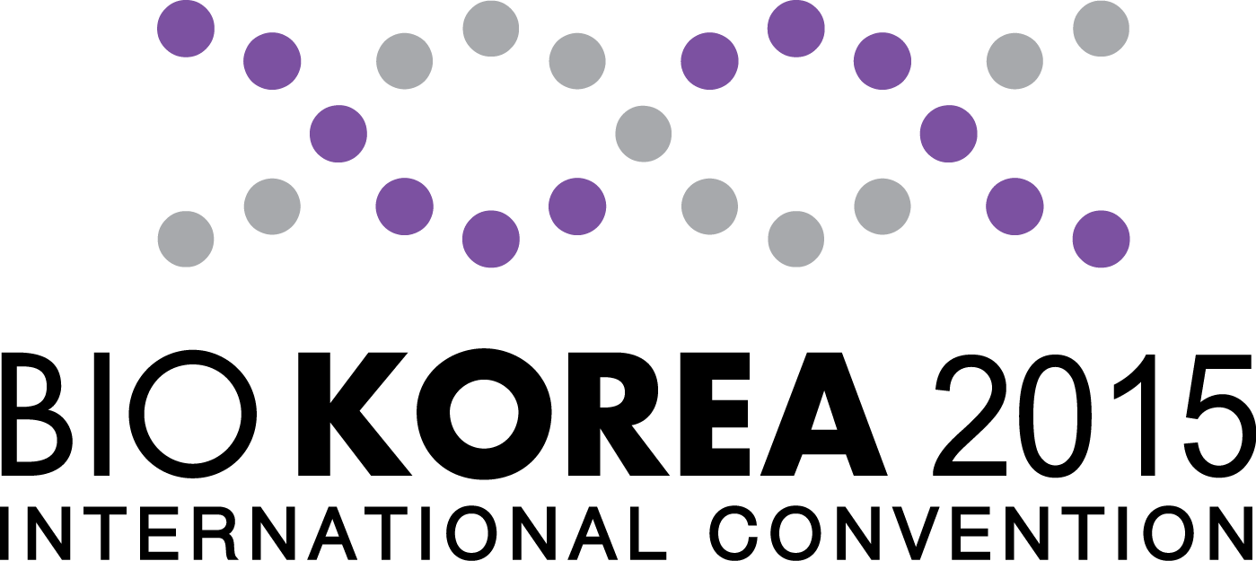
Entry Application

※ Upon submission of agreement, also please submit a copy of your business license
1. Company Information
Company  Name | Korean
Company  Name | English
CEO/President |  |  | Country
Address
Contact Person |  | - Mr. □ Ms. | Position
 |  |  | Department
Tel |  |  | Fax
Email |  |  | website

2. Exhibit Information
Product  Category | □ Medicine〮Chemical〮Bio | □ Medical Devices |  | □ Food/ Ingredients |  | □ Environment
Product  Category | □ Energy / Resources | □ Electronics (IT) |  | □ Process / Machinery |  | □ Information / R&D
Product  Category | □ Government / Organization / Institution |  | □ Press / Media / Magazine |  | □ Etcetera ( )
Introduction of Exhibits

3. Booth Application and Cost of Participation
Category | Unit Cost | Quantity |  | Total Cost | Remark
Space Only | 2,500 USD/Booth(9㎡) | Booth(s) |  | USD | Space Only
Standard Booth | 2,800 USD/Booth(9㎡) | Booth(s) |  | USD | Equipment cost Included
Discount rate | Early-bird registration (~Dec. 1, 2014) | 10% | □ | USD | Unit Cost × Discount Rate  × No. of Booths
Discount rate | Pre registration (~Jan. 30, 2015) | 5% | □ | USD | Unit Cost × Discount Rate  × No. of Booths
Discount rate | 2 Consecutive years participation  (2014 exhibitor ) | 5% | □ | USD | Unit Cost × Discount Rate  × No. of Booths
Total Cost |  |  |  | USD

※ Provision included with a Standard Booth: Partitions, Company Sign, Electrical Outlet 1ea, an Information Desk and Chairs 1 set, Carpeting, Electricity 1Kw
※ Discount Information: ① Early-bird registration (~Dec. 1, 2014) 10% ② pre-registration (~Jan. 30, 2015) 5% ③ 2 consecutive years participation 5%
※ Account Number : Nonghyup 301-0083-4208-11 Account Holder: BIO KOREA Organizing Committee
※ Deposit Payment : Deposit 50% of total cost within 1 week of submitting entry application (Discounts will not be applied unless deposits have been transacted.)
※ Balance Payment : until March 4th(Wed), 2015; For companies applying after this date, please pay total cost within 1 week
We accept the entry regulations and agreement conditions (recorded on reverse side), and also submit our business license and agree to execute the application and agreement to participate in BIO KOREA 2015.

Year Month Date

Manager (sign) CEO (sign)

The above person will serve as a representative of the exhibitor and will be warranted the rights and obligations to execute this agreement.

BIO KOREA Organizing Committee
[Tel : +82-1661-0810 / e-mail : exhibition@biokorea.org ]

Rules on Participation in Exhibition

Article 1  (Definition of Terms) |  | 1. "Exhibitor" refers to an exhibition exhibitor, such as an individual, company, institution or group, which has submitted the stipulated participation contract for participating in this Exhibition.  2. "Exhibition" refers to BIO KOREA 2015.  3. "Host Organization" refers to 'Korea Health Industry Development Institute, and Chungcheongbuk-do'  (Supervisor - BIO KOREA organizing committee).
Article 2  (Application for participation and Contract) |  | An individual or entity that wishes to participate in the Exhibition should prepare and submit to the Host Organization the participation contract and pay 50% of participation fee for the execution of the contract for participating in the Exhibition. However, in the event that it is considered that there is no space to display or the item for the Exhibition is not adequate for the Exhibition, the Host Organization may refuse to accept the application for participation.
Article 3  (Assignment of Booth Location) |  | 1. The Host Organization will assign the exhibition location according to the order of application and payment of participation fee and the nature of exhibit.  2. The Host Organization may change the assigned exhibition location, if it considers that such change is necessary for overall operation of exhibition hall, considering space balance, view efficiency, exhibition effect, etc. Such change will be made at sole discretion of the Host Organization, and the Exhibitor may not claim compensation for the result of change.
Article 4  (Management of Exhibition Hall) |  | 1. The Exhibitor should make best efforts to manage its own Booth by displaying the exhibit specified in the application form and designating its dedicated people for management.  2. In the event that the Exhibitor exhibits any items different from the exhibits specified in the application form or any items that are not adequate to the nature of exhibition, or attempts to directly sell any items without approval of the Host Organization, the Host Organization may order immediate suspension, evacuation or removal of the exhibit items. In such case, the participation fee will not be refunded and the Exhibitor may not claim for damage.  3. The Host Organization may restrict any access to the exhibit hall by the specified people, if necessary.  4. The Exhibitor must not assign nor transfer the assigned exhibition area to any third party, in whole or in part, without the written consent from the Host Organization.  5. The Exhibitor should operate and manage the exhibits within the scope that will not cause any damage to other exhibitors or visitors.  6. The Host Organization may order removal of any exhibits that have infringed other intellectual property right.  7. The Exhibitor must not change the original conditions of the exhibit hall by any acts, such as painting or nailing on the floor, ceiling or wall of the exhibit hall. The Exhibitor should compensate for any damages, such as restoration to the original conditions, to the Host Organization.
Article 5  (Payment Terms) |  | 1. The Exhibitor should make payment of the contract deposit equivalent to 50% of the participation fee within seven (7) days from the submission of the contract and then make full payment of the remaining amount no later than March 4, 2015(Wed.).  2. In the event that the Exhibitor fails to make payment within the specified date, the Host Organization may terminate the participation contract and may not claim for refund of any paid participation fee.
Article 6 (Termination) |  | 1. In the event that the Exhibitor refuses to use the assigned exhibit booth in whole or in part or fails to make payment of the participation fee within the specified period, the Host Organization, at its sole discretion, may terminate the participation contract and, in such case, will not refund any paid participation fee. Any renunciation of participation by the Exhibitor without the approval of the Host Organization will not be entitled to have refund of the participation fee.  2. In the event that the Exhibitor cancels its participation after submission of the application form, the Exhibitor should pay a cancellation fee specified in the following; provided, however, that any paid participation fee will be deducted as a cancellation fee and any shortage will be additionally paid or any surplus will be returned.  a) Cancellation no later than Jan. 31, 2015: Payment of 50% of the participation fee (exclusive of VAT) as a cancellation fee;  b) Cancellation from Feb. 1, 2015 to Feb. 28, 2015: Payment of 80% of the participation fee (exclusive of VAT) as a cancellation fee; and  c) Cancellation after March 1, 2015: Payment of 100% of the participation fee (exclusive of VAT) as a cancellation fee  3. Non-refundable participation fee will not be carried forward to the next participation fee for the next 'Exhibition'.
Article 7  (Cancellation or change of Exhibition) |  | In the event that the Host Organization cancels the Exhibition, it will refund the paid participation fees to the Exhibitor. However, in the event that the Exhibition is cancelled or its schedule is changed or reduced due to special circumstances not attributable to the Host Organization, such as Force Majeure, the participation fee will not be refunded. In such case, the Exhibitor may not claim for damage against the Host Organization.
Article 8  (Display of Equipment of Exhibition) |  | The Exhibitor should complete bringing-in and display of equipment and exhibits in the assigned exhibit area and within the specified period.
Article 9  (Taking-out of Equipment of Exhibition) |  | 1. The Exhibitor may not take out the exhibits before the end of exhibition.  2. The Exhibitor may take out all exhibits and equipment within the specified period. In case of any delay in taking-out, the Exhibitor should pay to the Host Organization any and all costs and expenses borne by the Host Organization.
Article 10  (Security, risk bearing and insurance) |  | 1. The Host Organization should take necessary security measures for the Exhibitors and visitor.  2. The Exhibitor should be liable for damage and loss of the equipment and exhibits placed within the assigned area that may occur during the period of exhibition or delivery/installation/removal of the exhibits.  3. In the event that the Host Organization or any third party has been damaged due to fire, loss or other accidents caused by the Exhibitor's intentional or negligent act, the Exhibitor should be responsible for compensation and should take up an insurance policy for its own exhibits.
Article 11  (Fire Prevention Rule) |  | All equipment and materials within the exhibition hall should be nonflammable-handled in an adequate manner in accordance with the fire defense laws and regulations.
Article 12  (Supplementary Provisions) |  | 1. The Host Organization may establish the supplementary provisions not specified in the Rules on Participation in Exhibition, if necessary.  2. The supplementary provisions will become an integral part of the Rules on Participation in Exhibition which the Exhibitor will comply with.  3. The Exhibitor should comply with any and all regulations of COEX.
Article 13  (Dispute Resolution) |  | Any dispute arising out between the Host Organization and the Exhibitor with respect to the interpretation of the Rules on Participation in Exhibition or any dispute in connection with the rights and obligations of both parties will be governed by the arbitration of the Korean Commercial Arbitration Center, and the decision of arbitration should be final and non-actionable to a court.

